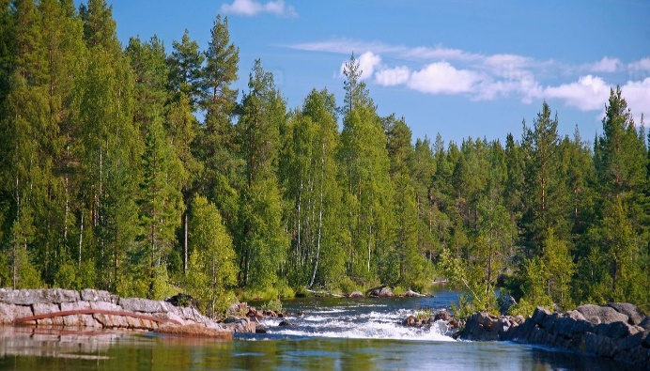
Women’s Retreat 2020
January 31-February 2
Telling Our Stories:
The River of Life

Friday Night
6:00 pm Dinner
7:00 to 9:00 pm Welcome, Introductions, and Holy Listening with Nancy Wade

Saturday Morning
7:30 am Yoga for all abilities with Diana Shellenberger (optional)
8:00 am Breakfast
9:00 am Session 1: Your Life as a River
10:00 am Small Group Sharing
11:00 am Break
11:15 am Session 2: River Guides
11:45 pm Small Group Sharing
12:15 pm Wisdom of the Whole
12:30 pm Lunch

Saturday Afternoon
1:30 pm Stretching with Diana
1:45 pm Break
3:45 pm Session 3: Soaked in the Spirit
4:30 pm Small Groups
5:45 pm Sparkling Cider and Wine
6:00 pm Dinner
7:15 pm Art with Susan Allman

Sunday Morning
7:30 am Yoga for all abilities with Diana
8:00 am Breakfast and Checkout of rooms
9:15 am Session 4: Wisdom and Calling from the River
9:45 am Small Groups
11:00 am Worship with Communion
Noon Depart for Home

