Sunday Morning
Wisdom from the River

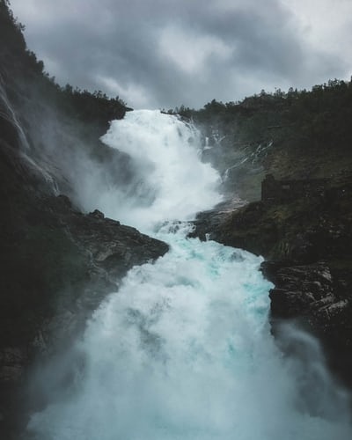
“Listening is an act of love.”
”The 40-minute StoryCorps interviews are structured so that in some ways we think of it as if you had 40 minutes left to live, what would you want to say to someone else? What would you want to learn about them? And in some ways, I think it’s maybe the best way to sum up who someone is in 40 minutes, although that’s a very difficult thing to do. But we have everything going for us, because it’s the voice, and it’s intimate, and it’s honest. I think of it as the opposite of reality TV. No one comes to get rich, no one comes to get famous, it’s just about generosity and love.”
– David Isay, founder of Story Corps

“Listen to your life. See it for the fathomless mystery it is. In the boredom and pain of it, no less than in the excitement and gladness: touch, taste, smell your way to the holy and hidden heart of it, because in the last analysis all moments are key moments, and life itself is grace.”
― Frederick Buechner, Now and Then: A Memoir of Vocation
Vocation does not come from willfulness. It comes from listening. I must listen to my life and try to understand what it is truly about—quite apart from what I would like it to be about—or my life will never represent anything real in the world, no matter how earnest are my intentions.
That insight is hidden in the word vocation itself, which is rooted in the Latin for “voice.” Vocation does not mean a goal that I pursue. It means a calling that I hear.
Before I can tell my life what I want to do with it, I must listen to my life telling me who I am. I must listen for truths and values at the heart of my own identity, not the standards by which I must live—but the standards by which I cannot help but live if I am living my own life.
Parker Palmer, Let Your Life Speak

Reflection

Looking back over your whole river, what lessons have you learned about life?

What wisdom about living do you want to carry into the future with you?

What gifts have you identified and developed over the course of your life’s river?

What wisdom and what gifts are you being called to share with others?

Where do you sense you are being called next on your river’s journey?

How do you want to be remembered?

