Saturday Morning
River Guides

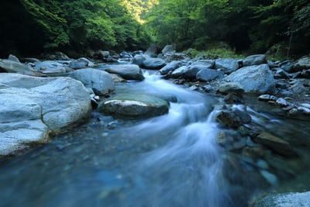

Returning to your river, think about the various people who have accompanied and guided you along your river’s journey.

What relationships have been most significant at different points in your life?
Who has most shaped you?

Have there been significant losses of relationships along the way?

What groups or communities of people were most important?

Record these key relationships and losses in the appropriate places on your river of life.

If you wish, you can also record thoughts and feelings attached to these relationships.

On Gratitude

by David Whyte

GRATITUDE is not a passive response to something given to us, gratitude is being awake in the presence of everything that lives within and without us.
Gratitude is not something that is shown after the event, it is the deep, a priori state of attention that shows we understand and are equal to the gifted nature of life.
Gratitude is the understanding that many millions of things come together and live together and mesh together and breathe together in order for us to take even one more breath of air, that the underlying gift of life and incarnation as a living, participating human being is privilege, that we are part of something, rather than nothing. Even if that something is temporarily pain or despair, we inhabit a living world, with real faces, real voices, laughter, the color blue, the green of the fields, the freshness of a cold wind, or the tawny hue of a winter landscape. To see the full miraculous essentiality of the color blue is to be grateful with no necessity for a word of thanks. To see fully, the beauty of a daughter’s face is to be fully grateful without having to seek a God to thank him. To sit among friends and strangers, hearing many voices, strange opinions; to intuit inner lives beneath surface lives, to inhabit many worlds at once in this world, to be a someone amongst all other someones, and therefore to make a conversation without saying a word, is to deepen our sense of presence and therefore our natural sense of thankfulness that everything happens both with us and without us, that we are participants and witness all at once.
Thankfulness finds its full measure in generosity of presence, both through participation and witness. We sit at the table part of every other person’s world while making our own world without will or effort, this is what is extraordinary and gifted, this is the essence of gratefulness, seeing to the heart of privilege. Thanksgiving happens when our sense of presence meets all other presences. Being unappreciative means we are simply not paying attention.

